A Data Science Approach to

Forecast Electricity Consumption in Australia

Brendan Chick (z5632728),
Daniel Heath-Ogden (z5623647),
Kam Kit Lau (z5618444),
Kelvin Yim (z5502200).

24/03/2026

Table of Contents
1 Introduction and Motivation 3
2 Preliminary Literature Review 3
3 Methods, Software and Data Description 4
4 Activities and Schedule 5
5 Team Roles 5
Appendix 1 6
Appendix 2 7
Appendix 3 8
References 9

1 Introduction and Motivation
Accurate electricity demand forecasting is critical for energy planning, grid stability, and efficient electricity market operation. Electricity providers rely on accurate forecasts to schedule generation, allocate resources, and maintain system reliability. Inaccurate predictions can lead to power shortages, inefficient generation scheduling, or increased operational costs. In addition, accurate forecasting provides economic advantages for stakeholders participating in energy markets.
This project focuses on forecasting electricity demand in New South Wales (NSW), Australia using historical demand data. Electricity demand is influenced by multiple factors, including seasonality, weather conditions, and user behaviour, making it inherently a time series problem with complex temporal dependencies. research question of the project is:
“Can transformer-based models (PatchTST) achieve lower forecasting error than traditional statistical models (SARIMAX) and recurrent neural networks (LSTM) for short to medium horizon electricity demand forecasting (48–720 hourly steps), as measured by RMSE and MAE?”
The primary objective of this study is to evaluate the effectiveness of modern machine learning models for predicting future electricity demand and to compare their performance with traditional statistical forecasting approaches. In particular, with the recent rise of transformer-based models, we investigate three distinct families of methodologies (discussed in Section 2):
- Statistical time series models (e.g., ARIMA/SARIMA),
- Long Short-Term Memory (LSTM) networks, a class of recurrent neural networks designed for sequential data,
- Transformer-based models (PatchTST), a modern deep learning architecture leveraging attention mechanisms.

The analysis is conducted across forecast horizons ranging from 48 to 720 time steps at hourly intervals (i.e., 2 to 30 days). This range is motivated by existing literature while also reflecting practical requirements for electricity providers, such as load planning and participation in energy markets (Feinberg et al., 2005; Hong et al., 2016).

2 Preliminary Literature Review
Electricity demand forecasting has been extensively studied due to its importance in power system operation and planning. Traditional statistical time series models such as Autoregressive Integrated Moving Average (ARIMA) and its seasonal variant (SARIMA) have long been used to model electricity demand due to their ability to capture trends and recurring seasonal patterns. These approaches have demonstrated strong performance in short-term forecasting tasks where demand follows predictable daily and weekly cycles (Box et al., 2015; Taylor, 2003). Their relative simplicity, interpretability, and low computational requirements make them a reliable baseline for comparison. Extensions of these models have also been applied to longer horizons, with studies showing that incorporating multiple seasonal components can improve forecasting accuracy over extended periods (Fan & Hyndman, 2012).
More recently, deep learning approaches have been introduced to better capture nonlinear relationships and complex temporal dependencies in electricity demand data. Long Short-Term Memory (LSTM) networks, a type of recurrent neural network, are particularly well suited to time series forecasting due to their ability to retain information over long sequences using gated memory cells (Hochreiter & Schmidhuber, 1997). In the context of electricity demand, LSTM models have shown strong performance when incorporating exogenous variables such as temperature, as well as lagged demand and calendar features. Studies such as Kong et al. (2017) and Marino et al. (2016) demonstrate that LSTMs can outperform traditional statistical models in short-term forecasting by effectively learning nonlinear demand patterns and temporal dependencies.
Despite their advantages, LSTM models have limitations when applied to medium- and long-term forecasting horizons. While they are capable of modelling long sequences, their predictive accuracy tends to decrease as the forecast horizon increases, as longer-term forecasts depend more heavily on stable trends and seasonal structures rather than short-term temporal relationships. Research such as Pełka and Dudek (2020) shows that hybrid or decomposition-based approaches, which combine statistical models with neural networks, can improve performance in these cases. This highlights the continued importance of classical methods and feature engineering when addressing forecasting horizons beyond short-term applications.
Transformer-based architectures have emerged as a newer approach for time series forecasting, offering an alternative to recurrent models by leveraging attention mechanisms to capture dependencies across long sequences. However, early work questioned their effectiveness in this domain, with studies showing that simpler statistical and machine learning models could outperform transformer-based approaches for long-term forecasting tasks (Li et al., 2022; Zeng et al., 2022). More recent developments, such as PatchTST (Nie et al., 2023), have addressed some of these limitations by introducing techniques such as patching and channel independence, improving performance on long-horizon forecasting benchmarks. These advancements suggest that transformer-based models may be more competitive when appropriately adapted for time series data.
Overall, the literature suggests that model performance in electricity demand forecasting is strongly dependent on the forecast horizon. Statistical models remain highly effective for short-term and structured seasonal forecasting, while LSTM models provide advantages in capturing nonlinear and short-term temporal dependencies. Transformer-based models show promise for long-term forecasting but require careful design and sufficient data to outperform simpler approaches.

3 Methods, Software and Data Description

3.1 Proposed Models
As the data follows a time-series, SARIMAX, LSTM and PatchTST will be implemented and compared — see Section 2. SARIMAX will serve as the baseline model.

3.2 Data Description
The project utilizes historical electricity demand data from New South Wales (NSW), spanning approximately the past ten years.
Target Variable: electricity demand (MW).
Explanatory Variables: temporal features (time of day, day of week, month, year), and temperature. Incorporating these variables is expected to improve forecasting accuracy by explicitly capturing seasonal and behavioural consumption patterns. The impact of temperature will be evaluated through controlled experiments. If it does not improve forecasting accuracy, it will be excluded to avoid introducing noise and unnecessary model complexity.

3.3 Methodology
- Exploratory Data Analysis (EDA): Examine seasonal patterns, demand cycles, and the critical relationship between temperature and electricity demand.
- Data Processing & Splitting: The dataset will be cleaned, pre-processed appropriately for each model, and subsequently split into training, validation, and testing sets.
- Forecasting Horizon: 48 up to 720 time-steps (equivalent to 2 to 30 days if hourly intervals).
- Training & Robustness: Models² will be trained and tuned on their respective pre-processed data. To improve robustness, the process will be repeated using multiple pre-defined seeds to compute the mean and standard deviation of the results.
- Evaluation Metrics: Model performance will be evaluated and compared using Mean Square Error (MSE) and Mean Absolute Error (MAE) aligning with the literatures reviewed in Section 2. To ensure a fair comparison between models, forecasts will be aligned at the timestamp level using a rolling window approach, allowing direct comparison of predicted and actual demand.

3.4 Software & Tools
The project utilises a range of tools to support effective collaboration, analysis, and communication and is presented in table 1 of Appendix 1. Microsoft Teams will be used for meetings and coordination due to its integrated chat, video, scheduling, and file-sharing capabilities within the university system. GitHub supported collaborative development through version control, branching, and project tracking, helping to minimise conflicts and maintain organisation. Python was selected for data analysis and modelling, given its extensive libraries and the team’s familiarity with the language. For reporting, Jupyter Notebooks were used to combine code, outputs, and explanations in a reproducible format, while Microsoft Word provided flexibility for formal academic writing. Finally, PowerPoint and recording software were used for presentations, enabling clear communication of results and flexible editing of recorded content.

4 Activities and Schedule
A Gantt chart is shown in Appendix 2 for the schedule of tasks prefixed with team members’ initial.
- Weeks 1 & 2 involve all team members up until pre-processing of data for their respective model.
- Weeks 3 & 4 continue with the implementation and tuning of the models. Then, their results are consolidated, and comparisons are made as described in section 3. Drafting of the final report will also begin.
- Week 5, finalization of the report with Brendan overseeing process.
- Weeks 6 & 7 are used for the final presentation of the project.

5 Team Roles
Responsibilities were allocated based on the individual expertise of team members (refer to table 2 of Appendix 3). Note that all team members have data analytics experience from UNSW courses and/or their occupations and therefore are responsible for various parts of data modelling and analysis. Brendan would be the research consultant, Daniel and Kam would be the presentation / communication leads and Kelvin would be the logistics coordinator. Kam would also be the project manager.

Appendix 1

Software
Table 1. Software choice and justification.
 | Justification
1. Meeting Software  – MS Teams | - Multifunction (chat, video, file sharing with University account) for efficient coordination and communication;  - Can schedule meeting and record meeting, with live caption;  - Compatible with University OneDrive.
2. Collaboration Tools  – GitHub | - With version control,  - Collaborative development through branches and pull requests, avoid conflicts,  - With tracking and project management features
3. Data Analysis Software  – Python | - Various choices of useful libraries (Pandas, NumPy, Scikit-learn, PyTorch etc),  - Suitable for coding statistical models and machine learning models,  - Team is familiar with this tool,  - Rich resources in Python available in GitHub
4. Reproducible Report Writing  – Jupyter Notebook + Word | - Jupyter Notebooks allows integration of codes, outputs, explanations in a reader-friendly format,  - Microsoft word provides flexibility for academic report writing  - Team is familiar with this tool
5. Oral Presentation Software  – Powerpoint  + Recording Software | - PowerPoint enables clear visual communication of key findings,  - Recording software enable asynchronous presentation delivery and teammate’s individual part can be edited easily into one single video,  - Allows rehearsal, re-take, correction, refinement with flexibility.
6. Additional Software

Appendix 2

Gantt Chart

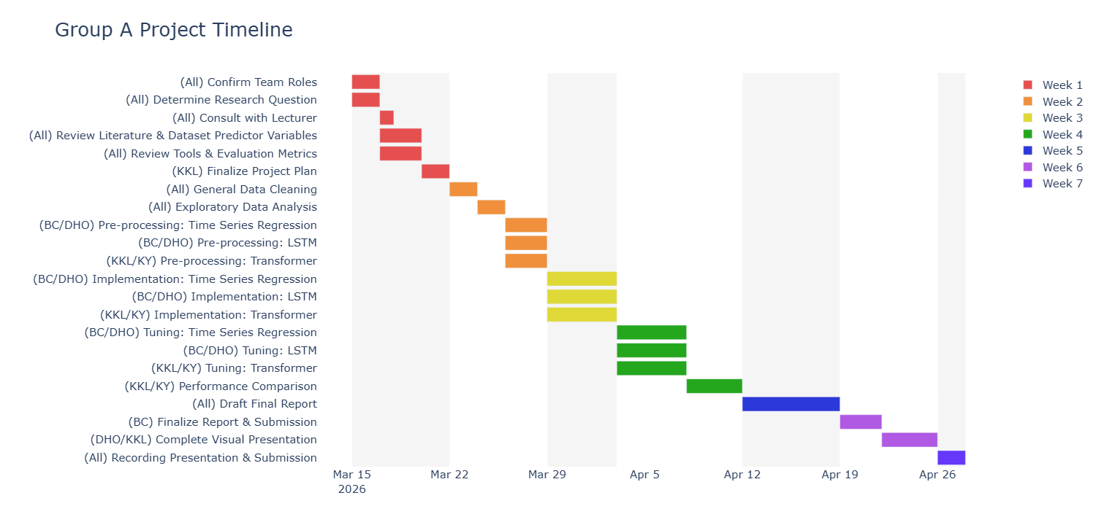
Figure 1. Gantt chart for the project.

Appendix 3

Team Roles
Table 2. Team member roles and responsibilities.
Member | Role / Responsibilities | Reasoning
Brendan | Research Consultant / Lead and Model analysis of SARIMAX + LSTM | Comprehensive research experience from PhD
Daniel | Presentation/Communication Lead and Model analysis of SARIMAX + LSTM | Teaching and tutoring experience
Kam | Project Manager, Presentation/Communication Lead², Model lead of PatchTST + Comparison | Highschool teaching + leadership experience as an actuary + UNSW Deep Learning course experience
Kelvin | Logistics coordinator and Model lead of PatchTST + Comparison | Stakeholder management experience from job + UNSW Deep Learning course experience

Mind Map of Expertise of Team Members
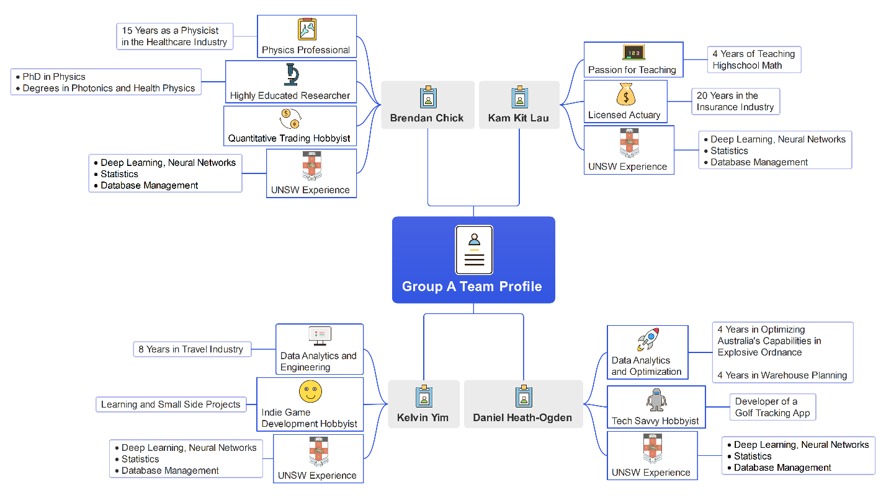
Figure 2. Team mind map.

References
1. Box, G.E.P., Jenkins, G.M., Reinsel, G.C. and Ljung, G.M. (2015), Time Series Analysis: Forecasting and Control, 5th edn, Wiley.
2. Fan, S. and Hyndman, R.J. (2012), ‘Short-term load forecasting based on a semi-parametric additive model’, IEEE Transactions on Power Systems, 27(1), pp. 134–141.
3. Hochreiter, S. and Schmidhuber, J. (1997), ‘Long short-term memory’, Neural Computation, 9(8), pp. 1735–1780.
4. Hippert, H.S., Pedreira, C.E. and Souza, R.C. (2001), ‘Neural networks for short-term load forecasting: A review and evaluation’, IEEE Transactions on Power Systems, 16(1), pp. 44–55.
5. Kong, W. et al. (2017), ‘Short-term residential load forecasting based on LSTM’, IEEE Transactions on Smart Grid, 10(1), pp. 841–851.
6. Li, H., Shao, J., Liao, K. and Tang, M. (2022), ‘Do simpler statistical methods perform better in multivariate long sequence time-series forecasting?’, CIKM.
7. Marino, D.L., Amarasinghe, K. and Manic, M. (2016), ‘Building energy load forecasting using deep neural networks’, IEEE IECON.
8. Nie, Y. et al. (2023), A Time Series is Worth 64 Words: Long-term Forecasting with Transformers, ICLR.
9. Pełka, P. and Dudek, G. (2020), Pattern-based LSTM for mid-term electrical load forecasting, arXiv:2004.11834.
10. Taylor, J.W. (2003), ‘Short-term electricity demand forecasting using double seasonal exponential smoothing’, Journal of the Operational Research Society, 54(8), pp. 799–805.
11. Vaswani, A. et al. (2017), ‘Attention is all you need’, NeurIPS.
12. Zeng, A. et al. (2022), Are transformers effective for time series forecasting?, arXiv:2205.13504.

Research consultant / lead: driving research direction and scrutinize results (e.g. Train/Validate/Test split, epochs, other hyperparameters), drive direction of research report
Presentation/Communication lead: driving direction and main message of video presentation to meet the objective of delivering the message on how data science approach is applied to solve daily life problem in simple language
Logistics coordinator: Driving discussion, communicate with lecturers, etc

